Table of Contents
Background | 2
Introduction | 2
Problem Statement | 2
Objectives | 2
Methodology | 3
Ethical Approval | 4
Questionnaire | 4
Data Collection | 4
Data Analysis | 6
Results and Findings | 6
Conclusion | 9
Recommendations | 9
References | 9

1. Background
Vaccination is one of the most effective public health interventions for preventing infectious diseases and reducing illness and death worldwide. Despite its proven effectiveness, vaccine hesitancy remains a significant public health concern due to misinformation, fear of side effects, religious misconceptions, and lack of awareness. University students are an important population because they influence their families and communities and represent future professionals. Understanding their knowledge and attitudes toward vaccination can help identify educational gaps and support awareness programs.
This project was conducted among undergraduate students of Iqra University, Islamabad Campus to evaluate their knowledge, perceptions, and attitudes regarding vaccination.
Background and study rationale are based on the approved proposal.

2. Introduction
Vaccines protect individuals and communities by preventing infectious diseases and reducing disease transmission. Although vaccines have successfully controlled diseases such as polio, measles, hepatitis B, and COVID-19, misinformation has reduced public confidence in vaccination.
This project aimed to assess students' vaccination knowledge, beliefs regarding vaccine safety, COVID-19 vaccination status, sources of vaccine information, and willingness to recommend vaccination.

3. Problem Statement
There is limited information regarding the knowledge and attitudes of university students toward vaccination in Pakistan. Increasing misinformation through social media and misconceptions about vaccine safety may negatively affect vaccine acceptance. Understanding these attitudes can assist in planning future awareness campaigns and educational interventions.

4. Objectives
General Objective
To assess the knowledge and attitudes of undergraduate students toward vaccination.
Specific Objectives
- Assess students' knowledge regarding vaccines.
- Evaluate attitudes toward vaccination.
- Determine COVID-19 vaccination status.
- Identify common sources of vaccine information.
- Examine reasons behind vaccine hesitancy.
- Assess willingness to recommend vaccination to others.

5. Methodology
Study Design
Cross-sectional descriptive survey.
Study Location
Iqra University, Islamabad Campus.
Study Population
Undergraduate students.
Sample Size
50 students.
Sampling Technique
Convenience sampling.
Data Collection Tool
A structured questionnaire prepared in Microsoft Excel.
Data Analysis
Data were entered into Microsoft Excel and analyzed using:
- Percentages
- Pivot Tables
- Pivot Charts
These methods summarized participant responses and illustrated trends.
Methodology details are consistent with the project proposal.

6. Ethical Approval
Ethical approval was obtained before beginning the study. Participation was voluntary, confidentiality was maintained, informed consent was obtained from all respondents, and no personal identifiers were disclosed.
Ethical approval documentation provided by the university.

7. Questionnaire
The questionnaire consisted of four sections:
Section A – Demographic Information
- Participant ID
- Name
- Department
- Location
Section B – Vaccination Knowledge
- Vaccination status
- COVID-19 vaccination status
Section C – Attitude Toward Vaccination
- Belief regarding vaccine safety
- Recommendation of vaccination
Section D – Sources of Information and Hesitancy
- Source of vaccine information
- Reason for vaccine hesitancy
The questionnaire was distributed electronically using Microsoft Excel.
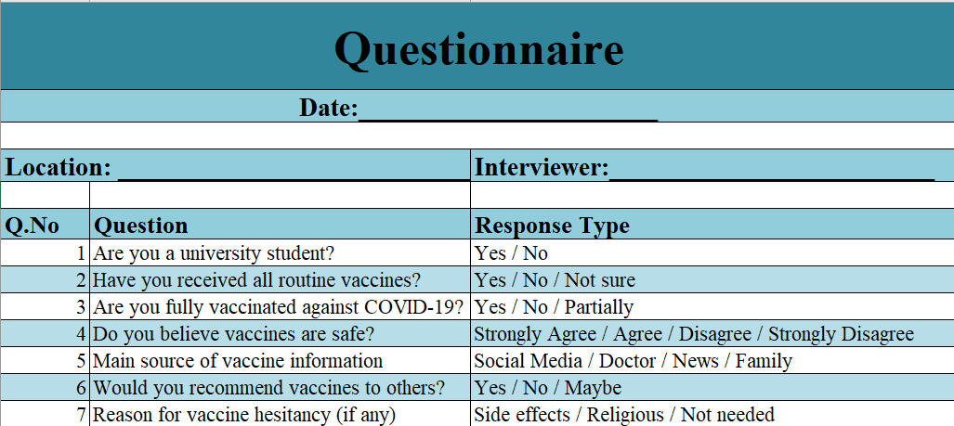

8. Data Collection
A total of 50 undergraduate students participated in the survey.
The responses were collected electronically and transferred into Microsoft Excel for analysis.
Departments included:
- Pharm-D
- Computer Science
- Software Engineering
- Artificial Intelligence
- BBA
- BFD
- International Relations
- English
- MLT
- MBA
- Others

9. Data Analysis
The collected data were analyzed using Microsoft Excel.
The following analyses were performed:
- Frequency distribution
- Percentage calculation
- Pivot Tables
- Pivot Charts
Variables analyzed included:
- Vaccination status
- COVID vaccination status
- Vaccine safety belief
- Information source
- Vaccine recommendation
- Hesitancy reasons
- Department-wise responses

10. Results and Findings
Participant Distribution
Total Participants = 50

Vaccination Status
Response | Frequency | Percentage
Yes | 39 | 78%
No | 6 | 12%
Not Sure | 5 | 10%
Finding:
Most students (78%) reported being vaccinated.

COVID-19 Vaccination Status
Response | Frequency | Percentage
Yes | 31 | 62%
No | 12 | 24%
Partially Vaccinated | 6 | 12%
Not Sure | 1 | 2%
Finding:
Nearly two-thirds of participants had received the COVID-19 vaccine.

Belief Regarding Vaccine Safety
Response | Frequency | Percentage
Strongly Agree | 22 | 44%
Agree | 27 | 54%
Disagree | 1 | 2%
Finding:
Almost all student’s believed vaccines are safe.

Source of Vaccine Information
Source | Frequency
Social Media | 35
Doctors | 8
Family | 4
News | 3
Finding:
Social media was the primary source of vaccine-related information.

Recommendation of Vaccination
Response | Frequency | Percentage
Yes | 43 | 86%
Maybe | 6 | 12%
No | 1 | 2%
Finding:
The majority of participants would recommend vaccination to others.

Reason for Vaccine Hesitancy
Reason | Frequency | Percentage
Side Effects | 45 | 90%
Not Needed | 5 | 10%
Finding:
Fear of side effects was the leading cause of vaccine hesitancy.

Departmental Participation
The highest number of respondents belonged to the Pharm-D department (17 students), followed by BBA, Computer Science, Software Engineering, and other disciplines.

Overall Findings
- Most students had been vaccinated.
- COVID-19 vaccination coverage was relatively high.
- Students generally trusted vaccine safety.
- Social media was the most common information source.
- Fear of side effects remained the main concern.
- Most respondents supported recommending vaccines to others.

11. Conclusion
The study indicates that undergraduate students at Iqra University generally possess positive attitudes toward vaccination. Most respondents were vaccinated, believed vaccines are safe, and were willing to recommend vaccination to others. However, concerns regarding side effects continue to contribute to vaccine hesitancy. Since social media is the primary source of vaccine information, universities and healthcare professionals should utilize digital platforms to provide accurate, evidence-based information and counter misinformation. Educational campaigns and awareness programs can further improve vaccine acceptance among university students.

12. Recommendations
- Conduct regular vaccination awareness seminars.
- Increase involvement of healthcare professionals in educational activities.
- Address misinformation on social media through evidence-based campaigns.
- Encourage students to obtain vaccine information from reliable health authorities.
- Conduct larger studies involving multiple universities in Pakistan.

13. References
- World Health Organization. (2023). Vaccines and Immunization.
- MacDonald, N. E. (2015). Vaccine Hesitancy: Definition, Scope and Determinants. Vaccine, 33(34), 4161–4164.
- World Health Organization. (2019). Ten Threats to Global Health.
- Pakistan Expanded Programme on Immunization (EPI). Ministry of National Health Services.
- Larson, H. J., et al. (2016). The State of Vaccine Confidence 2016. EBioMedicine.
These references are taken from the approved research proposal.

